|  |
| --- |
| Sydney Airbnb Open Data Executive Summary |
| Adithya Srinivas Bellamkonda(s5295811), Melvin Chavara(s5295081)Software TechnologiesOctober 7, 2023 |

# Abstract

This report outlines the capabilities of a data analysis tool designed for Sydney Airbnb listings, offering a suite of five core functions. Firstly, it enables users to pinpoint listings by suburb, extracting location-specific data from uploaded CSV files. Secondly, the tool generates price distribution graphs, giving users insights into pricing trends based on user-defined date ranges. Thirdly, it allows users to search for listings using keywords, extracting relevant data over specified timeframes. Fourthly, it assists in locating cleanliness-related comments within listings, helping users gauge sentiments on cleanliness. Lastly, the tool generates occupancy rate trend graphs, shedding light on property occupancy patterns over selected timeframes. These functionalities collectively empower users to conduct thorough analyses of Sydney Airbnb data, facilitating informed decision-making and trend identification.

# Introduction

This report delves into the functionality of a Sydney Airbnb data analysis tool, which offers a range of five key features. Firstly, users can conduct a suburb-specific search within uploaded CSV files, allowing them to extract listing details associated with a designated area. Secondly, the tool facilitates the generation of price distribution graphs, utilizing user-provided CSV data to present pricing trends over user-specified timeframes. Thirdly, it enables users to perform keyword-driven searches, extracting relevant listing data based on user-defined keywords and generating corresponding reports. Fourthly, the tool supports the search for cleanliness-related comments within listings, aggregating data that includes specified cleanliness keywords. Lastly, users can create occupancy rate trend graphs, offering insights into occupancy trends over selected time periods. These features collectively empower users to comprehensively analyze Sydney Airbnb data, aiding in decision-making and trend assessment.

# **Analysis 1 Search for Listings by Suburb**

For this Analysis user selects the Search for listings by suburb from the main menu of the application as shown in the image below.

After that application prompts another menu where the application asks the user to enter a suburb name in order to search for the listings after when user uploads the CSV file.

The below image shows the report for the suburb “Bondi Beach” from the CSV file listings_dec18.csv

# **Analysis 2 Generate a Price Distribution Graph**

For Analysis 2 when the user clicks on Generate a Price Distribution Graph from the main menu as shown in the image below.

After that, it will prompt the user to Enter the Start and End Date to generate the Analysis over that period of time, here the user has given 01-12-2017 as the start date and 24-12-2018 as the end date. After uploading the CSV file and clicking on the Generate Price Graph button the application generates the graph.

The below image shows the image of the generated graph over the period of time between 01-12-2017 to 24-12-2018 to give the price distribution graph.

# **Analysis 3 Search for Listings by Keywords**

The user clicks on Search for Listings by keywords analysis in order to this Analysis.

In the below image user enters the keyword in order to generate the report over a period of time, the below image user chooses to generate a report between 01-01-2017 to 01-12-2017 after uploading the CSV file.

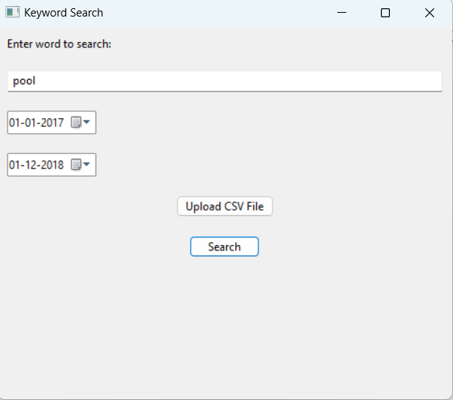

The below image shows the report generated over the period of time that the user has selected.

# **Analysis 4 Search for Comments on Cleanliness for Listings**

To do this Analysis user selects the Search for Comments on Cleanliness for Listings button in the main menu.

After that user will be prompted to enter a word to search in the field and upload the file to search for Cleanliness reviews.

The below image shows the regenerated report for the cleanliness analysis for the word “Clean”

# **Analysis 5 Generate an Occupancy Rate Trends Graph**

To do this Analysis user clicks on the Analysis button as shown the image below

**

After that, he will be prompted to upload a CSV file and select the period of time to generate the graph over that period. In the below image user selected from 01-10-2017 to 21-12-2018.

The below image shows the generated report for Analysis 5 over the period of time between 01-10-2017 to 21-12-2018

